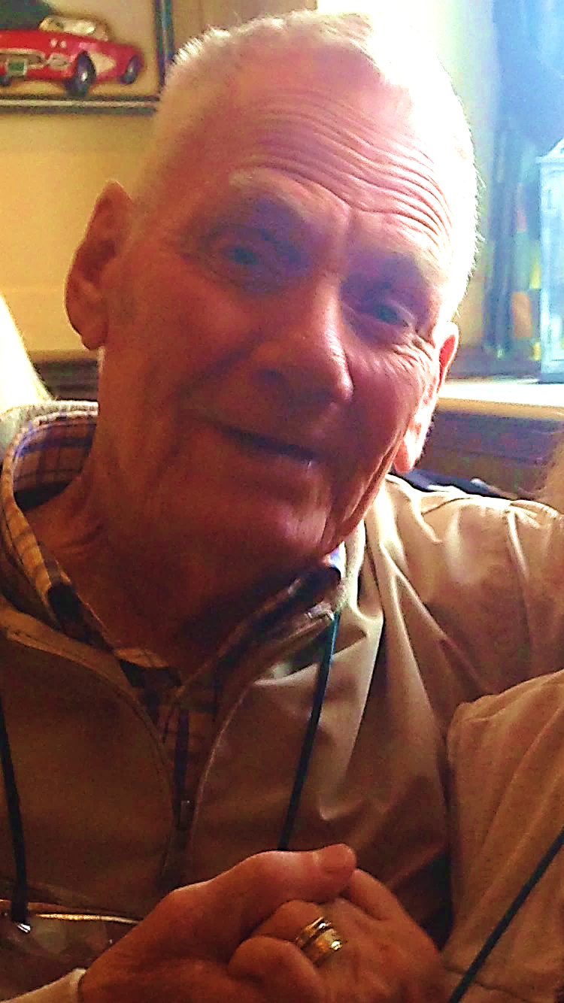

# To celebrate the life of

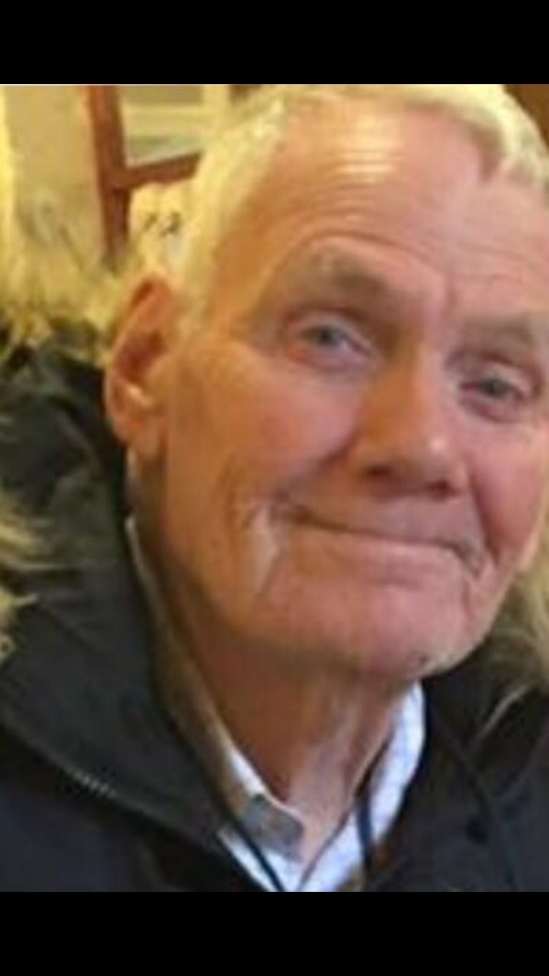

# George William Litherland

# 23rd November 1944 – 2nd December 2016

# Tuesday 20th December 2016

# St Andrew’s Church, Orford

# Order of Service

Entrance music: *Fly On* by Cold Play

#### **Introduction and Opening Prayers**

**All:** **Merciful Father, hear our prayers and comfort us; renew our trust in your Son, whom you raised from the dead; strengthen our faith that all who have died in the love of Christ will share in his resurrection; who lives and reigns with you, in the unity of the Holy Spirit, one God, now and for ever.**  **Amen**

**Hymn:** Make me a channel of your peace.

Where there is hatred let me bring your love.

where there is injury, your pardon, Lord,

and where there's doubt, true faith in you.

*Oh Master, grant that I may never seek*

*so much to be consoled as to console,*

*to be understood, as to understand,*

*to be loved, as to love with all my soul.*

Make me a channel of your peace.

Where there's despair in life, let me bring hope.

Where there is darkness, only light,

and where there's sadness, ever joy.

*Oh Master, grant that I may never seek ...*

Make me a channel of your peace.

It is in pardoning that we are pardoned,

in giving of ourselves that we receive,

and in dying that we're born to eternal life.

**The Scriptural Reading:** *John 14*. 1-6

**The Eulogy:** including tributes by Donna and Kadie

**Reflection:** *Dance with my father* by Luther Vandross

**The Prayers and Lord’s Prayer:**

*After “Lord, in your mercy”, please respond by saying: “****Hear our prayer”***

**Hymn: O Lord my God!** When I in awesome wonder

Consider all the works Thy hand hath made,

I see the stars, I hear the mighty thunder,

Thy power throughout the universe displayed:

*Then sings my soul, my Saviour God to Thee,*

*How great Thou art! How great Thou art!*

*Then sings my soul, my Saviour God to Thee,*

*How great Thou art! How great Thou art!*

When through the woods and forest glades I wander

And hear the birds sing sweetly in the trees;

When I look down from lofty mountain grandeur,

And hear the brook, and feel the gentle breeze;

*Then sings...*

And when I think that God his Son not sparing,

Sent Him to die - I scarce can take it in;

That on the cross my burden gladly bearing,

He bled and died to take away my sin:

*Then sings...*

When Christ shall come with shout of acclamation

And take me home - what joy shall fill my heart!

Then shall I bow in humble adoration  
And there proclaim my God, how great Thou art!

*Then sings ...*

**The Commendation and Blessing:** *(please stand)*

**All: Heavenly Father, in your Son Jesus Christ you have given us a true faith and a sure hope. Strengthen this faith and hope in us all our days, that we may live as those who believe in the communion of saints, the forgiveness of sins and the resurrection to eternal life; through Jesus Christ our Lord. Amen.**

Recessional music: *Dancing in the sky* by Dani and Lizzy